**Summer Holiday Clubs Information and Booking Details 2022**

Dear parent/carers,

Swift Sports Coaching are delighted to announce bookings are now open for the Summer 2022 holiday clubs.

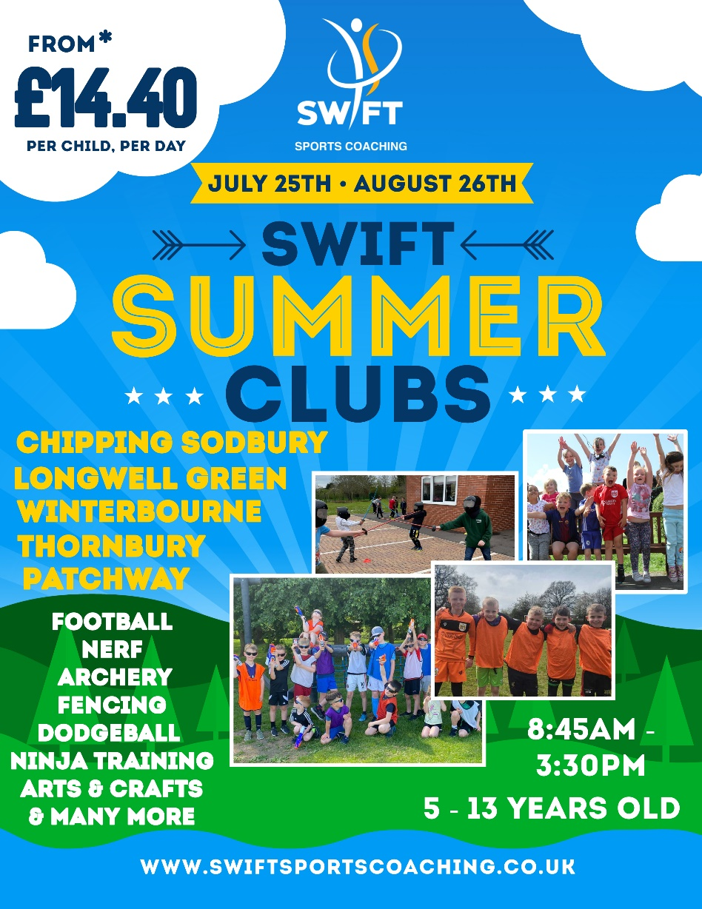

**Venues**

|  |  |  |  |
| --- | --- | --- | --- |
| **St John's Mead Primary School** | **Chipping Sodbury** | **BS37 6EE** | 8:45am - 3:30pm |
| **St Michael's Primary School** | **Winterbourne** | **BS36 1LG** | 8:45am - 3:30pm |
| **Longwell Green Primary School** | **Longwell Green** | **BS30 9BA** | 8:45am - 3:30pm |
| **\*\* St Chad’s Primary School ** NEW** | **Patchway** | **BS34 6AQ** | 8:45am - 3:30pm |
| **\*\* St Paul’s Primary School ** NEW** | **Yate** | **BS37 4EP** | 8:45am - 3:30pm |
| **\*\* Gillingstool Primary School ** NEW** | **Thornbury** | **BS35 2EG** | 8:45am - 3:30pm |

**Dates & Venues**

|  |  |  |  |  |  |  |  |  |  |  |
| --- | --- | --- | --- | --- | --- | --- | --- | --- | --- | --- |
| **St John’s Mead** (Chipping Sodbury)     /     **St Michael’s** (Winterbourne)     /     **Longwell Green** (Longwell Green) | | | | | | | | | | |
| **Week 1** |  | **Week 2** |  | **Week 3** |  | **Week 4** |  | **Week 5** |  | **Week 6** |
| Mon 25th July | Mon 1st Aug | Mon 8th Aug | Mon 15th Aug | Mon 22nd Aug | Closed |
| Tues 26th July | Tues 2nd Aug | Tues 9th Aug | Tues 16th Aug | Tues 23rd Aug | Closed |
| Wed 27th July | **Wed 3rd Aug** | **Wed 10th Aug** | **Wed 17th Aug** | **Wed 24th Aug** | Closed |
| Thurs 28th July | Thurs 4th Aug | Thurs 11th Aug | Thurs 18th Aug | Thurs 25th Aug | Closed |
| Fri 29th July | Fri 5th Aug | Fri 12th Aug | Fri 19th Aug | Fri 26th Aug | Closed |
| Each day we run multiple activities throughout the day, which children can pick and choose.  Activities include Nerf Battlegrounds, **Ninja Academy, Knight Skool, Dodgeball, Football,** plus much more.  Wednesday 3rd, 10th, 17th & 24th August - are **Wet Wednesdays**, A day of fun water games, include giant splash course, slip'n'slides, Water pistols | | | | | | | | | | |

|  |  |  |  |  |  |  |  |  |  |  |
| --- | --- | --- | --- | --- | --- | --- | --- | --- | --- | --- |
| **St Paul’s** (Yate)     /     **St Chad’s** (Patchway)     /     **Gillingstool** (Thornbury) | | | | | | | | | | |
| **Week 1** |  | **Week 2** |  | **Week 3** |  | **Week 4** |  | **Week 5** |  | **Week 6** |
| Closed | Mon 1st Aug | Mon 8th Aug | Mon 15th Aug | Mon 22nd Aug | Closed |
| Closed | **Tues 2nd Aug** | **Tues 9th Aug** | **Tues 16th Aug** | **Tues 23rd Aug** | Closed |
| Closed | Wed 3rd Aug | Wed 10th Aug | Wed 17th Aug | Wed 24th Aug | Closed |
| Closed | Thurs 4th Aug | Thurs 11th Aug | Thurs 18th Aug | Thurs 25th Aug | Closed |
| Closed | Fri 5th Aug | Fri 12th Aug | Fri 19th Aug | Fri 26th Aug | Closed |
| Each day we run multiple activities throughout the day, which children can pick and choose.  Activities include Nerf Battlegrounds, **Ninja Academy, Knight Skool, Dodgeball, Football,** plus much more.  Tuesday 2nd, 9th, 16th & 23rd August - are **Tidal Tuesday**, A day of fun water games, include giant splash course, slip'n'slides, Water pistols | | | | | | | | | | |

**Online Booking System**

We are also excited to inform you that Swift has a brand new booking system. The new booking system is exclusively online and is designed to make it easier and more accessible for parents and families to book. Although we really enjoy the aspect of regular dialogue with you via email conversation, whilst getting to know you and your children, the purpose of the new booking system means bookings can be made quickly and at your convenience.

**Click on the links Below to make Booking**

[Summer Holidays Clubs 2022](https://bookwhen.com/swiftsportscoaching-holidayclubs#focus=ev-si2w-20220725084500)

**Booking Discount**

**Special Multi-day discount** - Book any 10 days as a block and receive a 10% discount on your total booking.

**Sibling Discount - We offer a 10% discount on sibling bookings (booking anytime).**

Please note there are limited places available each day. If places are full, you will be asked if you would like to remain on a first come, first serve waiting list.

**Information & Booking Details**

* Days will run from 8.45am - 3.30pm
* Places will be allocated on a first come first serve basis
* Different activities & themes will run throughout the day, from Nerf, Ninja training, Archery, Skools Out and many more
* Government guidance will be adhered to
* Children will wash and sanitise hands frequently
* Children will need suitable clothing and footwear for indoor and outdoor use
* Children will need to bring their own packed lunch & drinks bottle
* Frequent cleaning will be undertaken of surfaces and areas of use
* Any child due to attend that develops Covid-19 symptoms may be asked not to attend.
* Anybody who develops symptoms whilst at the club may be isolated and sent home immediately and may not be able to re-attend until the 10 day isolation period is over or they have received a negative test result.
* Adults will not be allowed to enter the school and children will be kindly asked to be dropped to the doors where a member of staff will support signing in.
* Bookings are non refundable. Bookings may be transferred to another date at the discretion of Swift Sports Coaching.
* A 10% sibling discount is offered, per booking.
* All bookings will be made in line and subject to government guidelines and updates
* If Swift Sports Coaching has to cancel the week in line with government guidelines and updates, we will offer to postpone your canceled booking or offer a full refund.

**What to Bring**

* Appropriate clothing for outdoor play
* Packed lunch & snacks
* Refillable drinks bottle
* Sun cream
* Sun Hat

**By booking you are agreeing to the booking details outlined above.**

**Covid-19 safety policy & risk assessment**

You can find our latest Covid 19 safety policy and risk assessment on our website.

We look forward to hearing from you and receiving your booking information to secure your place. If you do have any further questions or queries please do not hesitate to contact us.

**Kind Regards,**

**Swift Sports Coaching**

**Tel: 07537 991 991**