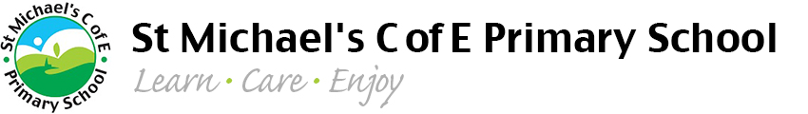
PE Funding 2020 -21
Primary sports funding document

Physical education Rationale
At St Michaels C of E Primary School, we believe in the development of sport and physical activity for all pupils so that participation and achievement levels can continue to rise. We have liaised with staff and children, encouraging collaboration and partnership, to make the best use of resources to enhance PE and sport through St Michaels. We believe it is important for children to experience participation in a wide range of team sports and be successful in a range of sporting disciplines.

This plan aims to structure raising standards of teaching throughout the school and support further opportunities for all pupils in a range of physical activity, both during the school day an out of school hours.
Our aims for this academic year have been based on the 4 key indicators that the government has outlined:
- The engagement of all pupils in regular physical activity – Chief Medical Officers guidelines recommend that primary school pupils undertake at least 30 minutes of physical activity a day in school
- Increased confidence, knowledge and skills of all staff in teaching PE and sport
- Broader experience of a range of sports and activities offered to all pupils
- Increased participation in competitive sport

How have we spent the sports premium funding?
Careful planning has been carried out to ensure the sports premium funding is used to enhance the current provision for physical education. We have taken into consideration the guidelines set out by the government and out local authority to ensure our funding is spent appropriately and effectively. This also includes careful consideration of the 4 key indicators that are laid out above which help schools measure their impact.
This year has undoubtedly been affected significantly by Covid-19 but there have still been opportunities to invest the sports premium money to make additional and sustainable improvements to the quality of our Physical Education provision.

